A.1 ANALYZE THIS PHOTO

What type of photo do you think this is? (check all that apply):

- Portrait
- Event
- Documentary
- Landscape
- Family
- Selfie
- Aerial/Satellite
- Panoramic
- Other
- Action
- Posed
- Candid

What do you see?

PEOPLE | OBJECTS | ACTIVITIES

Write one sentence summarizing the photo.

Where do you think this was taken?

When do you think it was taken?

What do you think this photo is trying to tell you?

What does it make you feel? (E.g. Angry? Happy? Sad?)

What do you like about the photo? (check all that apply)

- Composition
- Angles
- Lighting

- Colors
- Emotions
- Subjects

- Complexity
- Simplicity
- Other: ______
Explain why.
(Worksheet adapted from the National Archives)

A.2 COMPOSITION CHEAT SHEET
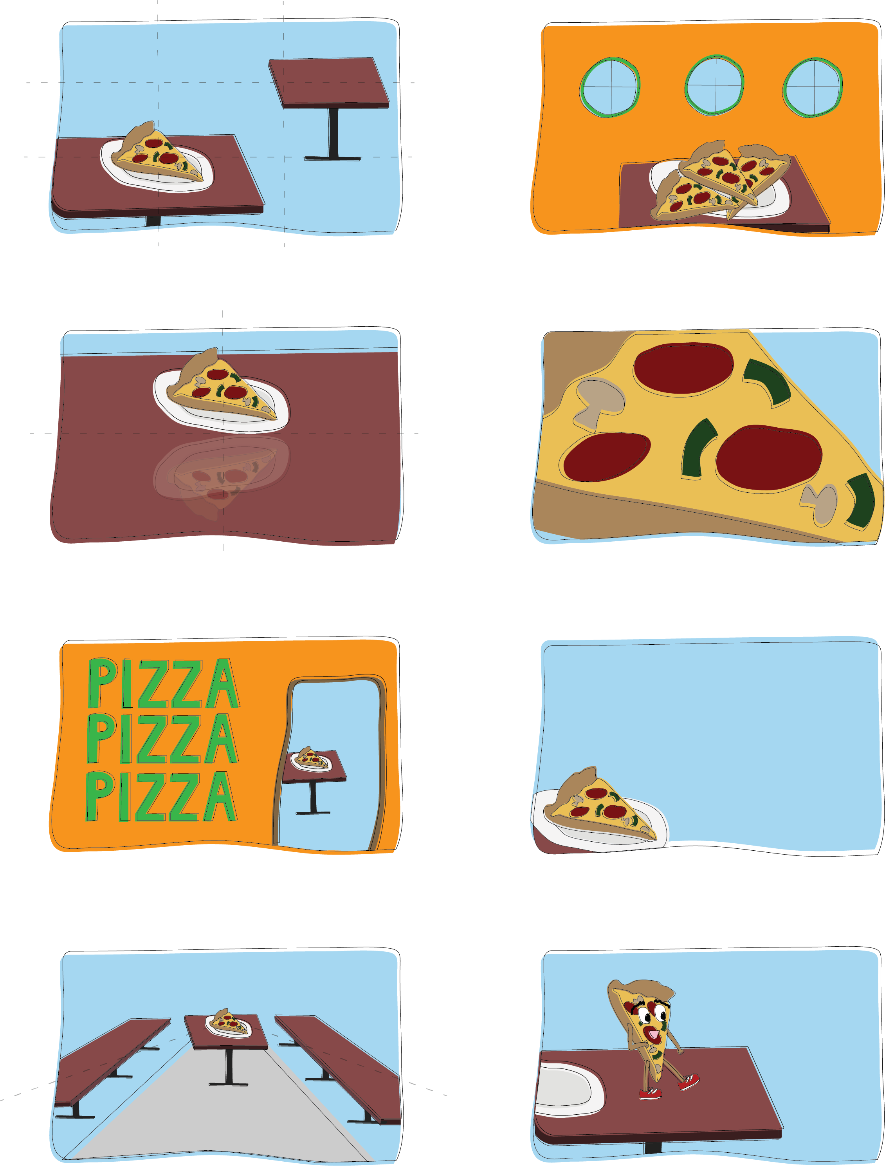
Rule of Thirds
Centering/Symmetry
Layers/Frame within a Frame
Leading Lines
Rule of Space
Leave Negative Space
Fill the Frame
Rule of Odds

A.3 PHOTO SCAVENGER HUNT
For this assignment, you will be given specific things to find and photograph. The things, however, should be special and unique and to you. When photographing, try to keep in mind the techniques discussed in class.

Find these things to photograph:

- A space in your home that you feel the most comfortable in
- Your favorite meal at home
- Your favorite part about your neighborhood
- Something you’ve had for over a year
- Something you’ve had for over 5 years
- Something you’ve had since you a baby
- Your favorite view out a window
- Your favorite thing about a friend
- Your favorite part of school
- Your favorite thing to do on the weekends
- Something that made you laugh
- Your favorite extracurricular activity
- Your favorite thing to do with family
- Your favorite thing to do with friends
- Your reflection in something other than a mirror

